BROOKDALE HOME & SCHOOL ASSOCIATION
Afterschool Enrichment: Fall Session
*Registration opens Sunday, September 16 @ 8pm*
ABOUT THE CLASSES

Classes are held Tuesday, Wednesday, or Thursday during the weeks of

September 24th through October 29th 2018.

TUESDAYS

Comics and Cartoons

Guaranteed to tickle the funny bone of every aspiring artist! Students will have a blast developing their own comic strips and graphic novels through instruction, reference material, and lots of drawing. Learn professional secrets and tricks of the trade from internationally syndicated Heathcliff cartoonist, Peter Gallagher. All skill levels welcome.

Who: Grades 2-6 When: Tuesdays, 3:30-4:30pm Cost: $70 per child.
Dates: September 25, October 2, 9, 16, 23, & 30.

Chess
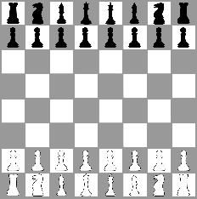
Take your chess game to the next level! Master fundamental chess strategies while earning trophies and prizes with lessons planned by New Jersey State Chess Champion Mackenzie Molner.

Who: All Ages When: Tuesdays, 3:30-4:30pm Cost: $80 per child
Dates: September 25, October 2, 9, 16, 23, & 30.

Cheerleading

Let’s Go Bobcats! Come out and learn some cheers with Miss Kelly. Students will learn cheers to cheer on the Brookdale Bobcats!

Who: Grades K-2 When:Tuesdays, 3:30-4:30pm Cost: $70 per child
Dates: September 25, October 2, 9, 16, 23, & 30.

WEDNESDAYS

Draw & Write with Mrs. Diorio

Draw a themed picture each week and respond to a writing prompt that goes along with it. Students will keep all drawings and writings in school to make a portfolio that will be sent home at the end of the 6 weeks.

Who: Grades K-2 When: Wednesdays, 3:30-4:30pm Cost: $70 per child
Dates: September 26, October 3, 10, 17, 24, & 31.

THURSDAYS

3D Design with Montclair Learning Center
Students will explore the design process through a variety of computer science programs. Classes will focus on architecture design, preparing items to be 3D printed off-site, coding-based 3D design, and more!

Who: Grades 3-6 When: Thursdays, 3:30-4:30pm Cost: $80 per child
Dates: September 27, October 4, 11, 18, 25, & November 1.

CSI Stem with Montclair Learning Center

You are the detective! Use your problem-solving skills and explore forensic science to solve a mystery. Students will engage in hands-on science experiments to analyze fingerprints, DNA, and clues using chromatography, macro and microscopic fiber analysis, and chemistry and toxicology to identify unknown substances and liquids. Students will engineer and test their own lie detector.

Who: Grades K-2 When: Thursdays, 3:30-4:30pm Cost: $80 per child.
Dates: September 27, October 4, 11, 18, 25, & November 1.

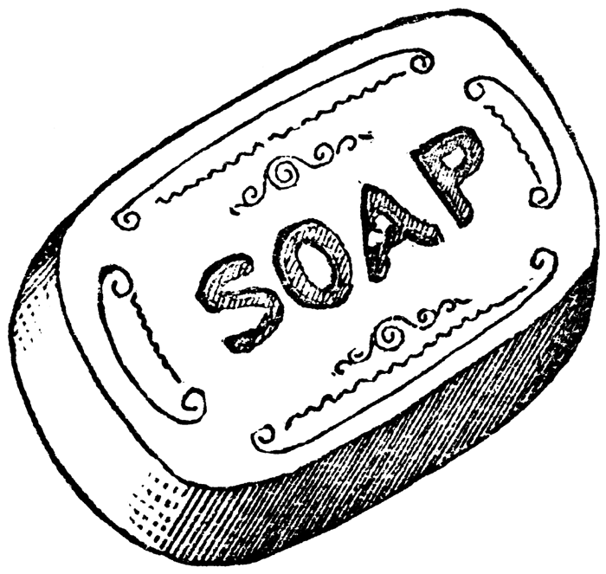
Soapmaking with Miss Kelly

All-natural soap making with Miss Kelly! Students will learn about the different kinds of soap bases (clear, white, aloe vera, coco butter, and Shea butter). We will learn about adding additives like oats, lavender buds, and coffee grinds to make a scrub soap. We will make soaps for the different seasons!

Who: Grades 3-6 When: Thursdays, 3:30-4:30pm Cost: $80 per child, 10 student limit
Dates: September 27, October 4, 11, 18, 25, & November 1.

Longboarding with Ms. H

Interested in picking up a hobby that is useful for transportation and fun? Join our class to learn and practice the basics of longboarding such as balancing, pushing along on your board, carving through cones, and stopping. Participants will be cruising around in no time! The following equipment is required to participate in the class: longboard OR skateboard, knee, elbow and wrist guards, and helmet.

Who: All Ages When: Thursday, 3:30-4:30pm Cost: $70 per child
Dates: September 27, October 4, 11, 18, 25, & November 1.

Class sizes will be limited to 15 children (except where otherwise noted) and space will be available on a first-come, first-served basis. Note that we may cancel classes if there is insufficient interest.

If you have questions, please contact Jackie Park Albaum (jparkalbaum@gmail.com) and Megan Wilt (megan.wilt@gmail.com).

Register online at https://07003fall18.brownpapertickets.com

